In this paper author describing concept to automate government services with Artificial Intelligence technology such as Deep Learning algorithm called Convolution Neural Networks (CNN). Government can introduce new schemes on internet and peoples can read news and notifications of such schemes and then peoples can write opinion about such schemes and this opinions can help government in taking better decisions. To detect public opinions about schemes automatically we need to have software like human brains which can easily understand the opinion which peoples are writing is in favour of positive or negative.

To build such automated opinion detection author is suggesting to build CNN model which can work like human brains. This CNN model can be generated for any services and we can make it to work like automated decision making without any human interactions. To suggest this technique author already describing concept to implement multiple models in which one model can detect or recognize human hand written digits and second model can detect sentiment from text sentences which can be given by human about government schemes. In our extension model we added another model which can detect sentiment from person face image. Person face expressions can describe sentiments better than words or sentences. So our extension work can predict sentiments from person face images.

To demonstrate how to build a convolutional neural network based image classifier, we shall build a 6 layer neural network that will identify and separate one image from other. This network that we shall build is a very small network that we can run on a CPU as well. Traditional neural networks that are very good at doing image classification have many more parameters and take a lot of time if trained on normal CPU. However, our objective is to show how to build a real-world convolutional neural network using TENSORFLOW.

Neural Networks are essentially mathematical models to solve an optimization problem. They are made of neurons, the basic computation unit of neural networks. A neuron takes an input (say x), do some computation on it (say: multiply it with a variable w and adds another variable b) to produce a value (say; z= wx + b). This value is passed to a non-linear function called activation function (f) to produce the final output (activation) of a neuron. There are many kinds of activation functions. One of the popular activation function is Sigmoid. The neuron which uses sigmoid function as an activation function will be called sigmoid neuron. Depending on the activation functions, neurons are named and there are many kinds of them like RELU, TanH.

If you stack neurons in a single line, it’s called a layer; which is the next building block of neural networks. See below image with layers

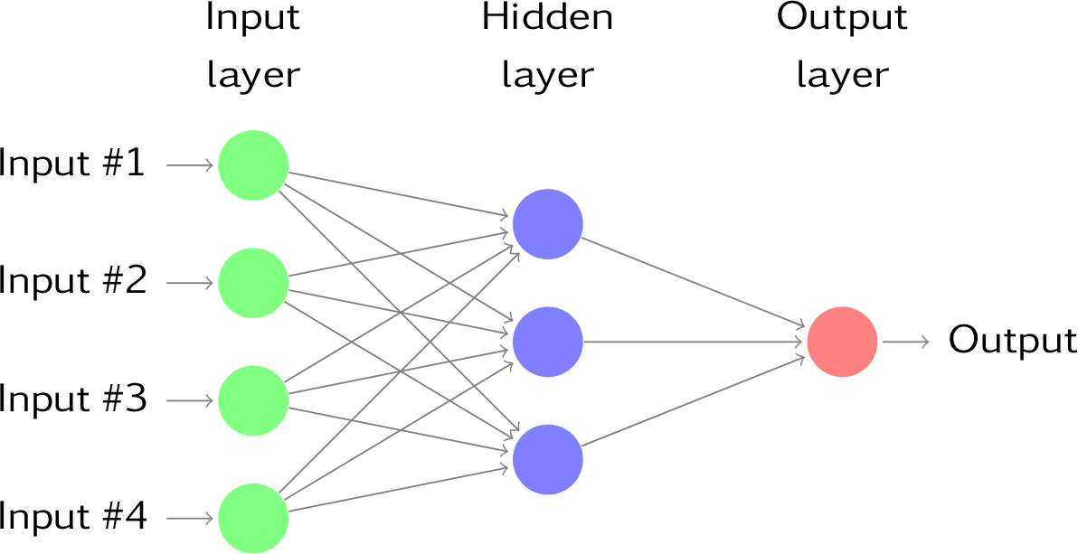

To predict image class multiple layers operate on each other to get best match layer and this process continues till no more improvement left.